Optimization of Inventory Management for Ronak Super Market.

A Proposal report for the BDM capstone Project

Submitted by

**Aniket Nagdare**

# Executive Summary :

The project focuses on a small grocery store, Ronak Super Market, located in the Chinchwad, Pune. This business is B2C and deals in daily use products such as rice, dal, sugar, and oils. The major business issues that the organization is facing include nominal profits due to large inventory stocks and inadequate sales forecasting, leading to problems like food wastage and product damage.

The issues will be addressed by analyzing the data through various analytical approaches, such as trend lines, scatter plots, and pivot tables, to obtain meaningful insights. The project aims to optimize inventory management, improve net profit margins, and enhance the store's market reach.

The expected outcome is to help the organization reduce the money blockage in terms of inventory, ultimately increasing the profitability and efficiency of the store.

# Organization Background :

**Name** : Ronak Super Market

**Owner** : Mr. Ramesh Choudhary

**Address** : Kakade Park , Keshav Nagar, Chinchwad, Pune. 411033

* Ronak Super Market is a standard kirana shop that specializes in the sale of daily use products such as Dal , Sugar , salt , Oils , Ghee , Dry Fruits etc ..
* This retail establishment was established in early 2015. The proprietor of the store has put a total of three lakhs into the business, with some of that money going toward fixed assets like the building and some going into variable assets like the merchandise.
* As a result of my conversation with the owner of the store and some analysis on my part, I have discovered that the store was operating fairly well before the increase of online marketing system ans since then there is a tremendous fall down in sales and profit Margins

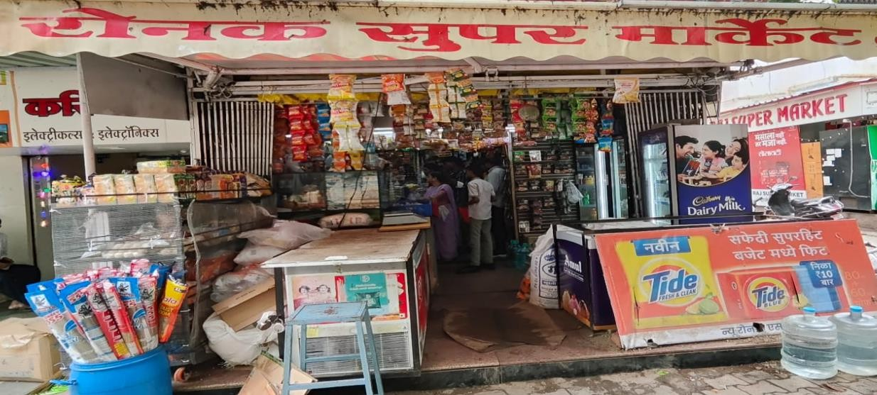

(Pic of Shop)

# Problem Statement (Listed as objectives):

* 1. **Problem Statement 1:** Optimize inventory management practices to minimize wastage and enhance operational efficiency through streamlined inventory control and predictive analytics.
  2. **Problem Statement 2:** Analyze current financial metrics and implement strategies aimed at boosting the net profit margin by optimizing pricing strategies, reducing costs, and increasing sales efficiency.
  3. **Problem Statement 3:** Expand market reach and competitiveness by conducting a comparative analysis of store performance metrics against industry competitors, identifying strengths and weaknesses to capitalize on market opportunities.

# Background of the Problem:

* After a detail discussion with Owner, i concluded that the store was performing well before the boom of online shopping, and as a result of covid lockdown many of the old customers have shifted to online shopping due to great discount and home delivery comfort
* The primary issues identified include inadequate sales forecasting and improper inventory management. This results in overstocking, leading to food wastage and product damage. Additionally, pricing issues for certain products like dry fruits and oils have been noted, making them more expensive compared to other shops. Addressing these issues through a thorough analysis of the business will help in identifying appropriate and workable solutions.

After giving all of these a lot of thought, I have come to the conclusion that the best way to make use of the information, skills, and tools that were taught in the course is to identify appropriate and workable solutions through a thorough analysis of the business.

# Problem Solving Approach:

To solve the identified problems, the following approaches will be implemented based on the collected data:

1. **Data Collection and Cleaning:** Collecting time-series data for key products (rice, atta, dals, sugar, oil, ghee, milk and dairy, dry fruits) over 14 days. The data includes cost price, selling price, quantity sold, and quantity bought.

## Data Analysis:

* + **Trend Analysis:** Using trend lines and scatter plots to identify sales patterns and predict future sales.
  + **Pivot Tables:** Creating pivot tables to filter and compute data row/column-wise, allowing for detailed analysis of sales and inventory.
  + **Financial Ratios:** Calculating key financial ratios such as ROCE, Gross Profit Ratio, and Net Profit Ratio to assess financial health.

## Inventory Optimization:

* + **ABC Analysis:** Categorizing inventory items based on their importance and sales frequency to prioritize management efforts.
  + **EOQ Model:** Implementing the Economic Order Quantity model to determine the optimal order quantity that minimizes total inventory costs.

## Pricing Strategy:

* + **Competitor Analysis:** Comparing product prices with competitors to adjust pricing strategies accordingly.
  + **Promotional Offers:** Suggesting promotional offers and discounts to attract customers and boost sales.

## Market Reach:

* + **Customer Feedback:** Collecting feedback from customers to understand their preferences and improve service quality.
  + **Digital Presence:** Enhancing the store’s digital presence through social media and local online marketplaces to reach a broader audience.

## Visualization and Reporting:

* + **Data Visualization:** Using pie charts, stacked histograms, and heat maps to present findings and insights visually.
  + **Reporting:** Preparing detailed reports with actionable recommendations for the store owner.

# Expected Timeline:

I have successfully collected 14 days worth of data which will be first cleaned , analyzed according to which more data will be collected if needed

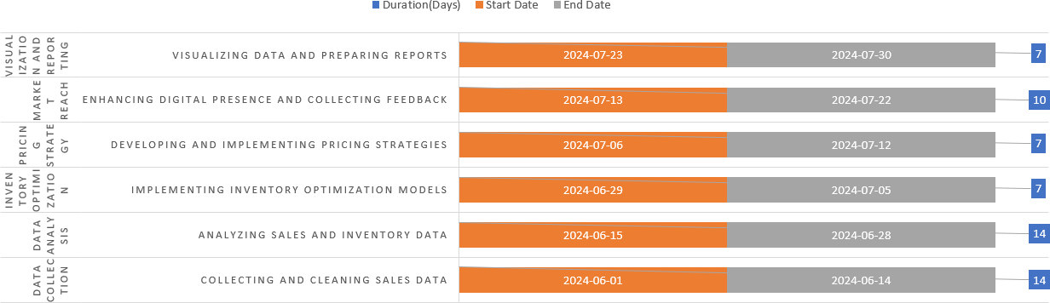

Gantt Chart

# Expected Outcome:

* 1. **Better Inventory Planning :-**

The project will provide insights into which products are more frequently sold and which ones are slow-moving, enabling better inventory planning and reducing wastage.

* 1. **Reduction in Returns :-**

Identifying the main reasons behind returns and high return percentage products will help in formulating strategies to minimize returns.

* 1. **Enhanced Market Reach :-**

The project will offer a better understanding of the demographic distribution of customers, allowing for targeted marketing and promotions to enhance market reach.

* 1. **Improved Profit Margins :-**

By optimizing inventory and implementing effective pricing strategies, the store's profit margins are expected to improve significantly.